BLANTYRE SECONDARY SCHOOL CLUSTER
2021 MSCE MOCK EXAMINATIONS
MATHEMATICS
Question Number | Tick if answered | Do not write in these columns
1
2
3
4
5
6
7
8
9
10
11
12
Date: Friday, 6 August Subject Number: M131/II
Time Allowed: 2 hours 30 min
8:00 am – 10:00 am
PAPER II
(100 marks)
Instructions
1. This paper contains 9 printed pages. Please check.
2. Answer all the six questions in this paper in Section A and any four questions in Section B.
3. The maximum number of marks for each answer is indicated against each question.
4. Write your answers in the spaces provided on the question paper.
5. Scientific calculators may be used.
6. All working must be clearly shown.
7. Write your Name at the top of each page of this question paper in the spaces provided.
8. In the table provided on this page, tick against the question number you have answered.

© 2021 BSS CLUSTER Turn over

SECTION A (60 marks)
Answer all the six questions in this section.

1.(a) The third term of an arithmetic progression is 14 and the 7th term is 30. Find the first term.

(5 marks)
(b) The deviations from mean of set of data is , , and . Find the possible value of x.

(5 marks)

2. (a) The volume of a triangle with the base 4 cm is 40 cm³. Find the base of the similar triangle with
the volume of 5 cm³.

(6 marks)
(b) Without using a calculator or four figure tables simplify leaving your answer with a
rational denomination.

(4 marks)

3. (a) Make y the subject of formula.

(4 marks)

(b) Figure 1 shows a circle PQRS with centre O. XPY is a tangent to the circle at P. Angle
QPY=50° and angle ROQ =70°. XSOR is a straight line.
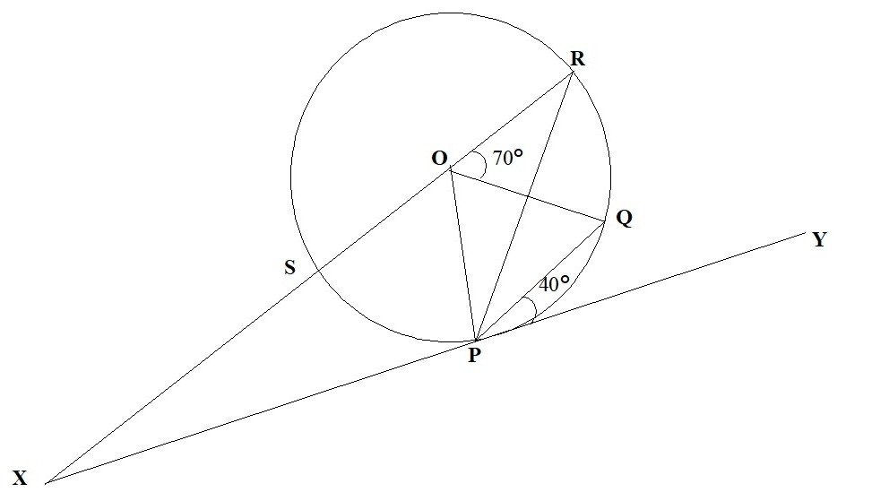

Calculate the value of angle OXP.

(6 marks)

4. (a) Given that the root of a quadratic equation in x are, -4 and , Formulate the equation in the form of ay²+by+c=0

(5 marks)

(b) Given that Log₁₀5 = 0.6990. Without using a calculator or four figure tables evaluate Log_{c} C²-
log₁₀2.

(5 marks)

5(a) Simplify ÷

(5 marks)

(b) Using a pair of compasses and a ruler only, construct in the same diagram construct,

- A circle centre O with radius 3 cm.
- Tangent PT at P such that PT = 6 cm.
- Measure and state OT.

(6 marks)

6. (a) The angle between line AB and the X axis is 45°. Given that the coordinates of A and B are (2, 0)
and (x, 4) respectively, calculate the value of X.

(5 marks)

(b) The volume of a cone is 4950 cm³. If the height of the cone is 21 cm³, find its radius.
(Take π = ) and volume = .

(5 marks)

SECTION B (40 MARKS)

7. Factorise completely.x³ + 6x²y + 3xy² - 10y³.

8. Solve the following simultaneous equations

(10 marks)
9. Ո is the algebraic sum of two terms one of which varies directly as ս and the other inversely as ս².
If Ո = 11, when ս = 2 and when Ո = 25.16, when ս = 5, calculate Ո when ս = 3.

(10 marks)

10. Solve the equation 2^{3a+3} – 2^{a+3} – 2ª + 1 = 0

(10 marks)

11. Mr Phiri would like to buy a second hand laptop and a desktop. He has a total of K2400000 to
buy laptops and desktops. Each laptop costs K60,000 and each desktop costs K80,000. He
plans to buy not less than 20 computers altogether and at least 4 desktops.

(a) If X represents the number of laptops and Y the number of desktops, formulate three inequalities
that satisfy the information above in addition to x + y ≥ 20.

(b) Using scale of 2 cm to represent 5 units on both axes, draw graphs on the graph paper provided to
show the region represented by the four inequalities by shading the unwanted region.

(c) Mr Phiri wishes to make a profit of K10, 000 for selling a laptop and K20, 000 for selling a
desktop. Use the graphs to find the maximum number of laptops and desktops he can buy to
make maximum profit.

(10 marks)

12. The table below shows some values of x and y for the equation y = x² – x - 2.

x | -2 | -1 | 0 | 1 | 2 | 3 | 4
y | 4 |  | -2 | -2 | 0 |  | 12

- Complete the table of values.
- Using a scale of 2 cm to represents 1 unit on the horizontal axis and 2 cm to represent 2 units on the vertical axis, draw the graph of y = x² – x - 2

(c) Use your graph to solve the equation x² – x – 5 = 0

13. The first term of an AP is 3, and its first fourth and thirteenth terms form a geometric progression
(GP)

(i) If the common difference of the AP is d, write down the expression for the fourth and thirteenth
term.

(ii) Find d.

(iii) Calculate the sum of the first 10 terms of the GP.

(10 marks)
END OF PAPER

